Project 1

CSC 4320

Hyunki Lee

#002-34-4677

Part1

The following screenshot is showing when the program runs with make, ls, insmod, rmmod command.

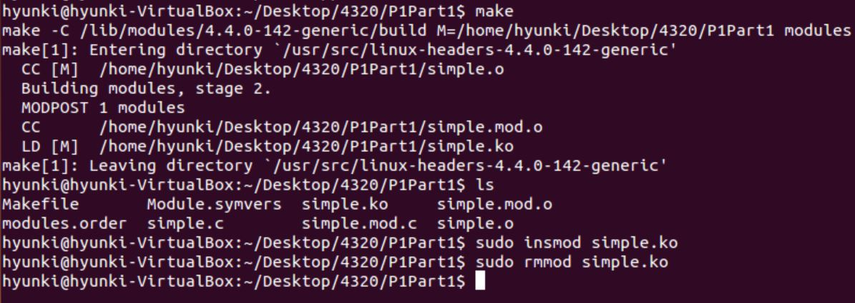

The following screenshot present to run dmesg command.

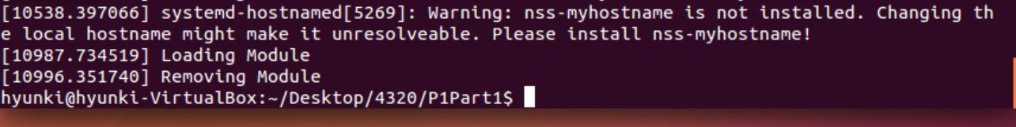

Part2

The following screenshot shows when ‘make’ command is used.

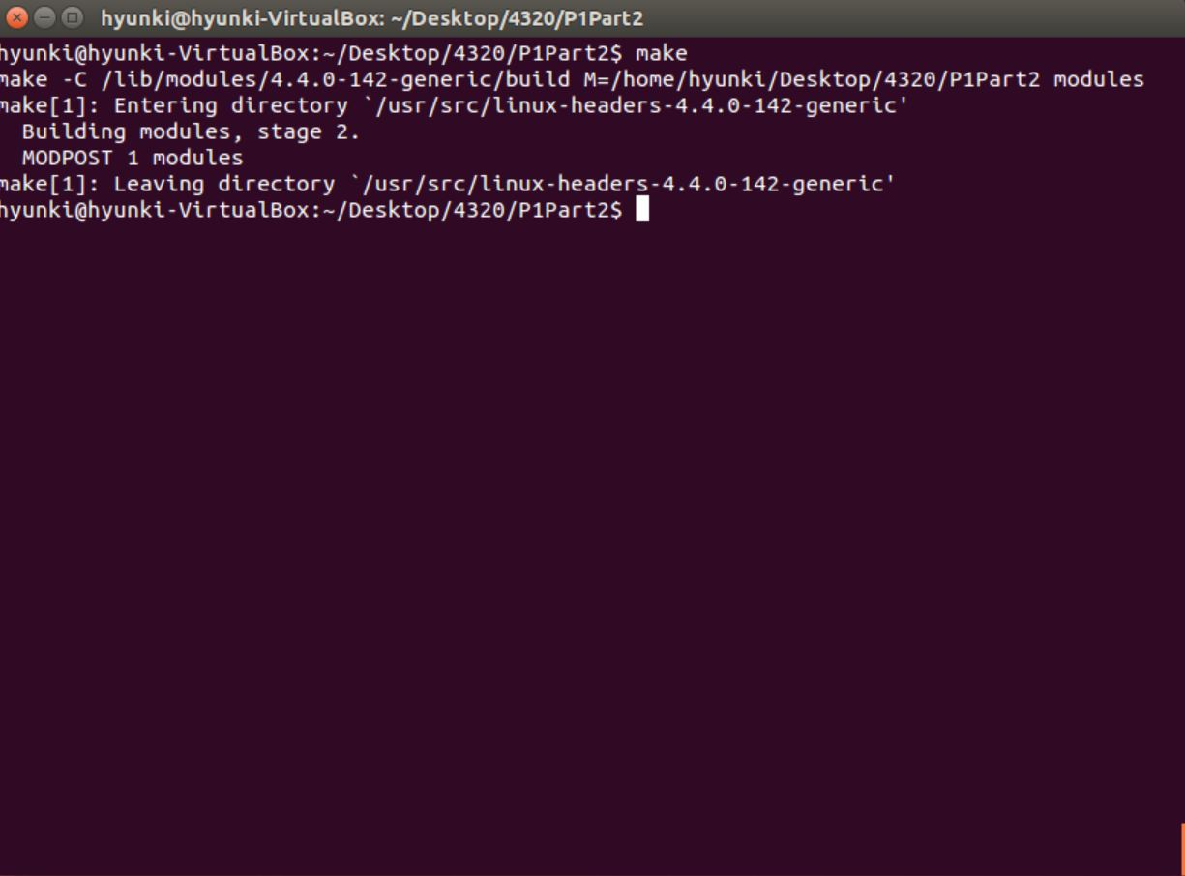

Then using ‘insmod’ and ‘rmmod’ command.

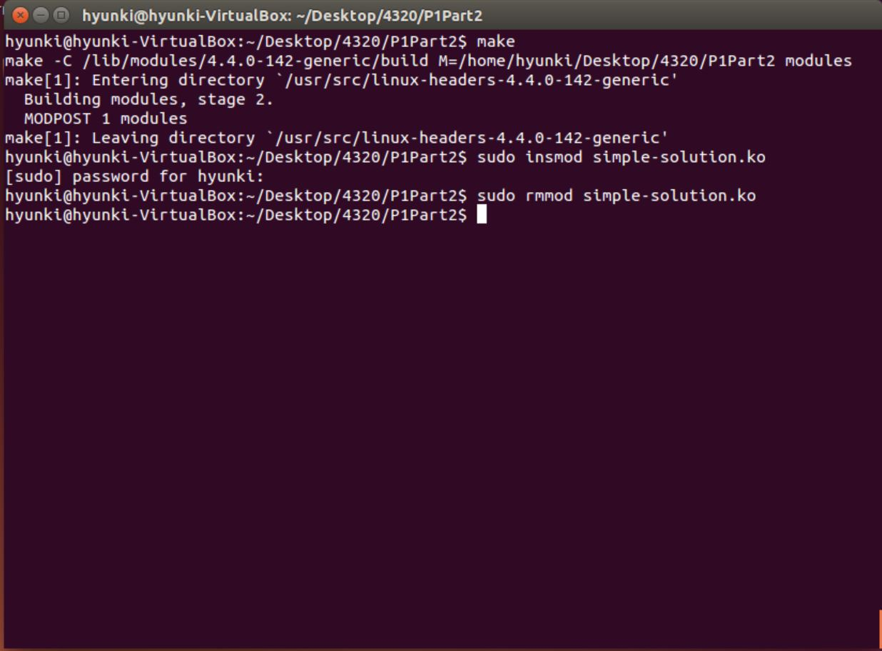

Finally, using the ‘dmesg’ command to see the kernel log buffer.

